WEB APPLICATION.

Havi Assignment

# Project Overview:

* This application is created for the assignment purpose for Havi .
* In this project User can login and sign up to their account.
* The project function is that when a user logs in, its show them a page with a list creator. There is a text box into which the user can enter something and on press of enter, the items will be added to the database and populate the updated database in the list.
* There is a admin grid where the list of all users can be seen in a grid.
* APIs are handle data to be processed with all the forms and make it a functional application.

# Productive Tools:

* PHP
* MySQL
* HTML
* CSS
* BOOTSTRAP

# Objectives:

* User/employee can send their feedbacks.
* Admin can see all of the feedbacks.

# Description:

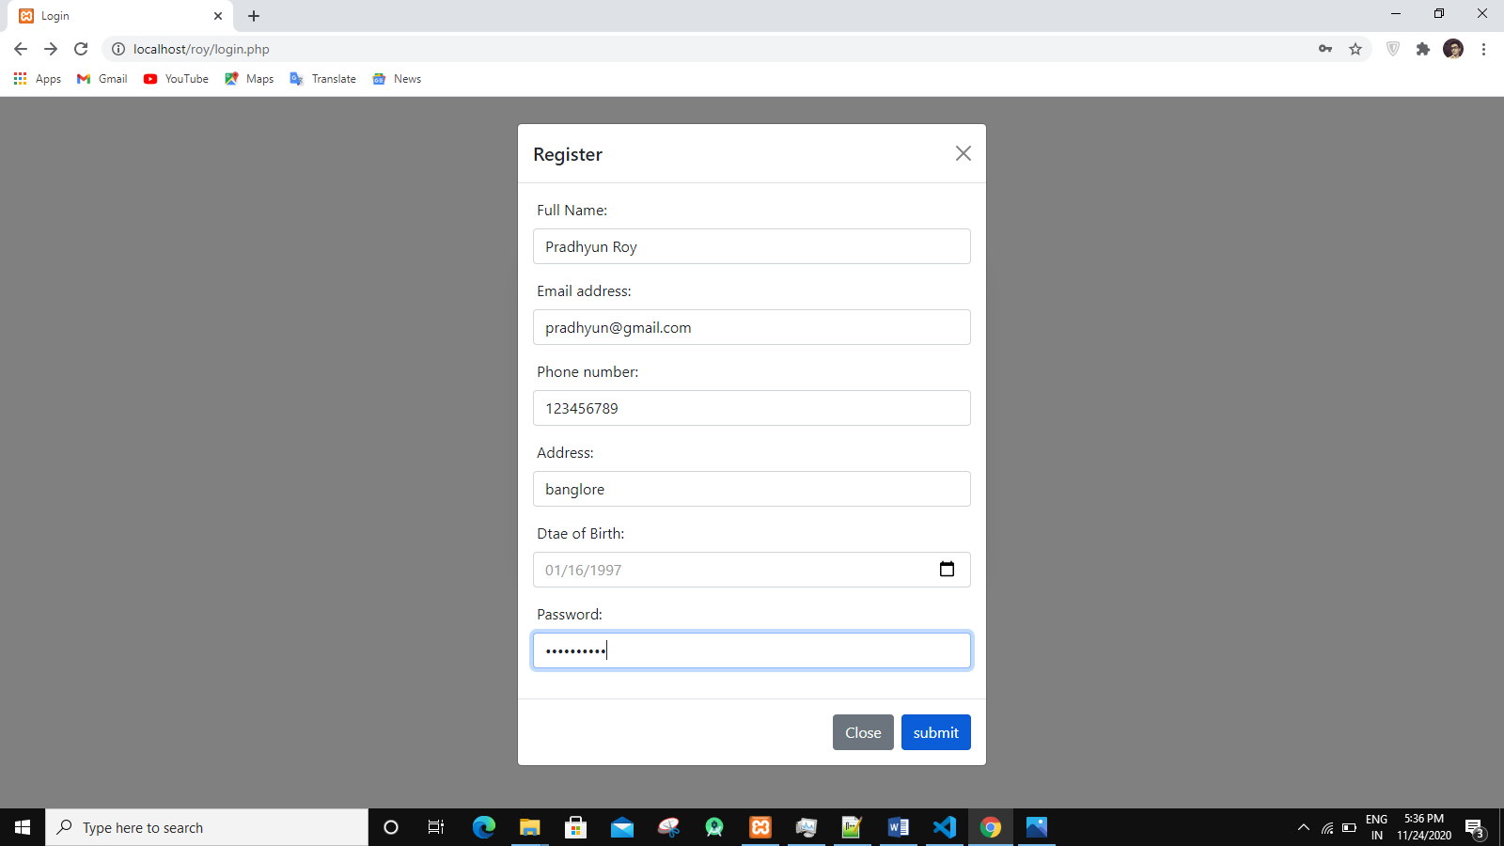

* Above picture is showing the registration page where user can fill his/her some information and register in the site.
* 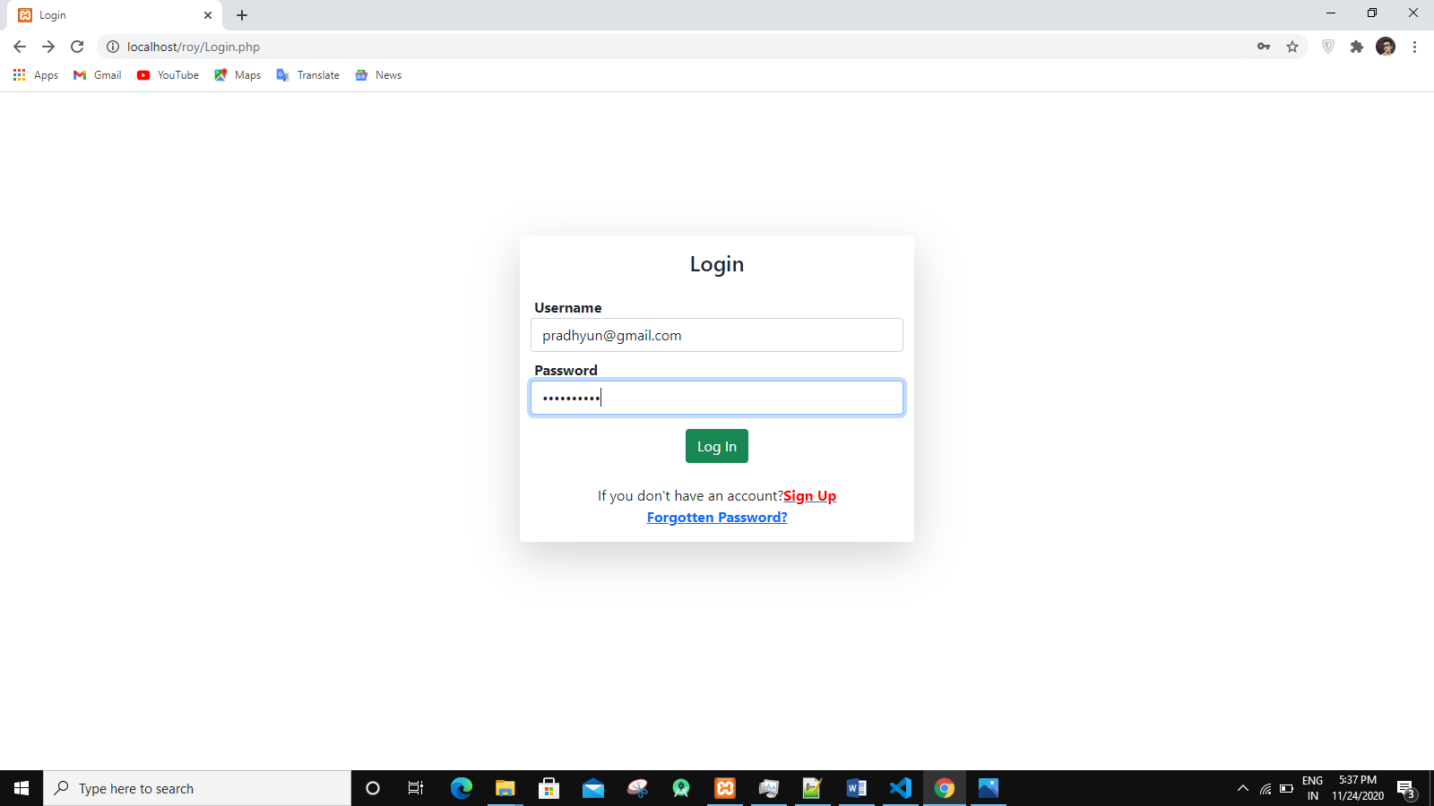Above picture is showing the login page where user can fill their E-mail and password to login.

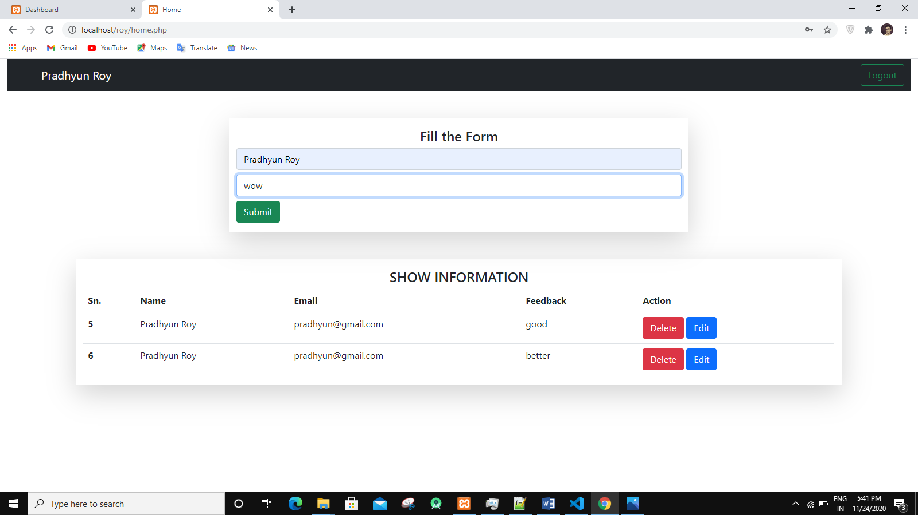

* Above picture is showing the feedback page where user can fill their name and feedback.

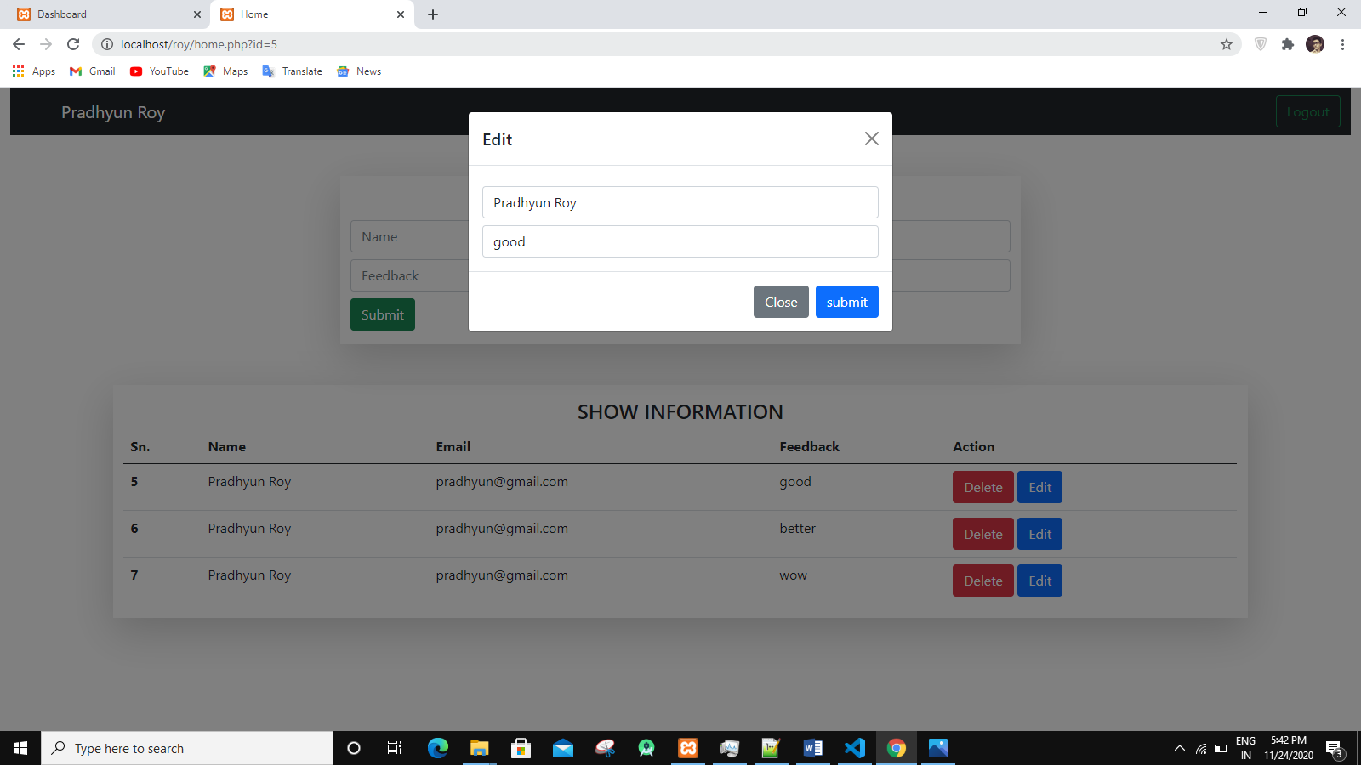

* Above picture is showing the edit page where user can edit their feedback.

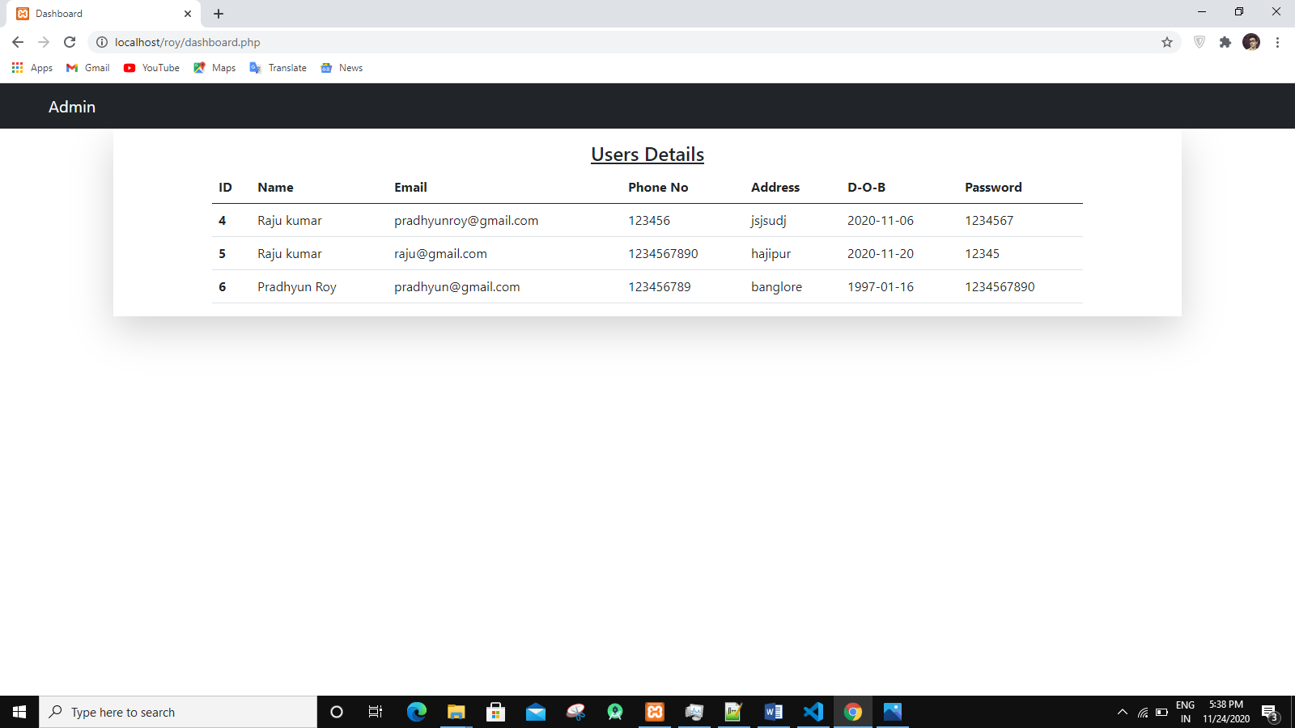

* Above picture is showing the Admin page where admin can see all of the feedback.

# Summarize what you learned:

* Web Devlopment

# Link of the project: